**AIRLINE RESERVATION SYSTEM**

**AIM:**

To develop an application for Airline Reservation System using the programming language JAVA and Swing.

**INTRODUCTION**:

The Airline Reservation System has been developed to override the problems prevailing in the manual system. This system is supported to eliminate the hardships faced by the existing system. Moreover this system is designed for the company to carry out operations in a smooth and effective manner. This system is user-friendly and requires no formal knowledge.

**SCOPE**:

Airline Reservation System was introduced to render better service to passengers. This system has broadened the working and availability of service area. On one hand, it helps the customers and on the other, it also makes the life of the airline service companies easier by keeping all the records of the passengers in reserve and if there is any change in the fight due to some reason, the passengers are swiftly notified. Furthermore, this system is feasible for the customers as it makes reservation and cancellation much easier and faster. This system is also used by companies to keep track of user preferences of regular travelers so that they can provide better service and give offers to customers.

**HARDWARE REQUIREMENTS:**

Processor: IntelPentium based system

Processor: 250MHz to 833MHz

RAM Speed: 1GB

Minimum 60 MB of free disk space for files.

**SOFTWARE REQUIREMENTS:**

Windows OS or Linux or MacOS

SQL for Backend

Eclipse IDE

Microsoft word

**ALGORITHM:**

**LOGIN:**

Step 1: Start

Step 2: Import the necessary packages.

Step 3: Create a derived class named ‘Login’ which is derived from the ‘Frame’ class and implements ActionListener.

Step 4: Import the necessary packages.

Step 5: Declare the corresponding variables for the class TextField, Label and Button.

Step 6: Declare the necessary menus.

Step 7: Using actionPerformed() method, user can perform an action.

Step 8: Launch the scene.

**MAIN MENU:**

Step 1: Start.

Step 2: Import the necessary packages.

Step 3: Create a class named MainMenu extends Frame implements ActionListener.

Step 4: Let this class contain MenuBar, Menu and MenuItem and declare the corresponding variables for each class.

Step 5: Using addActionListener(this) method, take the current class object as a parameter.

Step 6: Using setSize() and setTitle() method, set the size and title for the MainMenu.

Step 7: Launch the scene.

**PASSENGERS DETAILS:**

Step 1: Start.

Step 2: Import the necessary packages.

Step 3: Create a class named Create extends Frame implements ActionListener.

Step 4: Declare the corresponding variables for the class TextField, Label and Button.

Step 5: Using add() method, add a specific element into a Set collection.

Step 6: Create a derived class named ‘W’ derived from ‘WindowAdapter’.

Step 7: Invoke windowClosing() method to de-activate a window.

Step 8: Launch the scene.

**RESERVATION:**

Step 1: Start.

Step 2: Import the necessary packages.

Step 3: Create a class named Reservation extends Frame implements ActionListener.

Step 4: Declare the corresponding variables for the class TextField, Label, Font and Button.

Step 5: Create a derived class named ‘W’ derived from ‘WindowAdapter’

Step 6: Invoke windowClosing() method to de-activate a window.

Step 7: Launch the scene.

**CANCELLATION:**

Step 1: Start.

Step 2: Import the necessary packages.

Step 3: Create a class named Reservation extends Frame implements ActionListener.

Step 4: Declare the corresponding variables for the class TextField, Label, Font and Button.

Step 5: Using addActionListener(this) method, take the current class object as a parameter.

Step 6: Using actionPerformed() method, user can perform an action.

Step 7: Create a derived class named ‘TU’ derived from ‘WindowAdapter’

Step 8: Invoke windowClosing() method to de-activate a window.

Step 9: Launch the scene.

**FLOWCHART:**

Login

Book Flight

No

Confirm Booking

bb

Yes

Reserve

Cancellation

**SOURCE** **CODE**:

**LOGIN**:

import java.awt.*;

import java.awt.event.*;

public class Login extends Frame implements ActionListener{

String username = "admin";

String password = "admin";

TextField t1,t2;

Label l1,l2,l3,l4,l5,l6;

Button b2,b3,b4;

GridBagLayoutgbl;

GridBagConstraintsgbc;

Font f1,f2;

public Login(){

setTitle("Login Screen");

g = new GridLayout(4,2,0,60);

setLayout(g);

setBackground(Color.Grey);

f1 = new Font("TimesRoman",Font.BOLD,20);

f2 = new Font("TimesRoman",Font.BOLD,15);

gbl=new GridBagLayout();

gbc=new GridBagConstraints();

setLayout(gbl);

l1 = new Label("Username",Label.CENTER);

l1.setFont(f1);

l2 = new Label("Password",Label.CENTER);

l2.setFont(f1);

l3 = new Label("");

l4 = new Label("");

l5 = new Label("");

l6 = new Label("");

t1 = new TextField(15);

t2 = new TextField(15);

t2.setEchoChar('*');

b2 = new Button("Reset");

b2.setFont(f2);

b3 = new Button("Submit");

b3.setFont(f2);

b4 = new Button("Close");

b4.setFont(f2);

gbc.gridx=0;

gbc.gridy=0;

gbl.setConstraints(l1,gbc);

add(l1);

gbc.gridx=2;

gbc.gridy=0;

gbl.setConstraints(t1,gbc);

add(t1);

gbc.gridx=0;

gbc.gridy=2;

gbl.setConstraints(l2,gbc);

add(l2);

gbc.gridx=2;

gbc.gridy=2;

gbl.setConstraints(t2,gbc);

add(t2);

gbc.gridx=0;

gbc.gridy=4;

gbl.setConstraints(l3,gbc);

add(l3);

gbc.gridx=2;

gbc.gridy=4;

gbl.setConstraints(l4,gbc);

add(l4);

gbc.gridx=0;

gbc.gridy=6;

gbl.setConstraints(b2,gbc);

add(b2);

gbc.gridx=2;

gbc.gridy=6;

gbl.setConstraints(b3,gbc);

add(b3);

gbc.gridx=0;

gbc.gridy=8;

gbl.setConstraints(l4,gbc);

add(l4);

gbc.gridx=2;

gbc.gridy=8;

gbl.setConstraints(l5,gbc);

add(l5);

gbc.gridx=0;

gbc.gridy=10;

gbl.setConstraints(b4,gbc);

add(b4);

add(l1);

add(t1);

add(l2);

add(t2);

add(b1);

add(b2);

add(b3);

add(b4);

b1.addActionListener(this);

b2.addActionListener(this);

b3.addActionListener(this);

b4.addActionListener(this);

}

public Insets getInsets(){

return new Insets(40,40,40,40);

}

public void actionPerformed(ActionEvent ae){

if(ae.getSource()==b2){

t1.setText("");

t2.setText("");

}

if(ae.getSource()==b4){

System.exit(0);

}

if(ae.getSource()==b3){

if((t1.getText().equals(username))&&(t2.getText().equals(password))){

MainMenu m = new MainMenu();

setVisible(false);

m.setSize(400,400);

m.setVisible(true);

m.setTitle("Main Menu");

}

else{

Warning w = new Warning();

w.setSize(300,200);

w.setVisible(true);

w.setTitle("Message Box");

MessageBox mb = new MessageBox(this);

mb.setLocation(200,200);

mb.setVisible(true);

}}

if(ae.getSource() == b1){

Change c = new Change();

c.setSize(400,400);

c.setVisible(true);

c.setTitle("Screen for Changing Login Details");

}}}

**CHANGE LOGIN:**

import java.awt.*;

import java.awt.event.*;

public class Change extends Frame {

Label l1,l2;

TextField t1,t2;

GridLayout g;

Button b1,b2;

Change(){

g = new GridLayout(3,2,20,40);

setLayout(g);

l1 = new Label("Username",Label.CENTER);

l2 = new Label("Password",Label.CENTER);

t1 = new TextField(20);

t2 = new TextField(20);

t2.setEchoChar('*');

b1 = new Button("Submit");

b2 = new Button("Close");

b2.addActionListener(new W());

addWindowListener(new L());

add(l1);

add(t1);

add(l2);

add(t2);

add(b1);

add(b2);

}

class W implements ActionListener{

public void actionPerformed(ActionEvent ae){

if(ae.getSource()==b2){

dispose();

}}}

class L extends WindowAdapter{

public void windowClosing(WindowEvent e){

setVisible(false);

//dispose();

System.exit(0);

}}

public Insets getInsets()

{

return new Insets(40,40,40,40);}

public static void main(String args[]){

Change m = new Change();

m.setTitle("Change Login Details");

m.setSize(400,300);

m.setVisible(true);

}}

**MESSAGE BOX:**

import java.awt.*;

import java.awt.event.*;

public class MessageBox extends Dialog implements ActionListener{

GridBagLayout gbl;

GridBagConstraints gbc;

//FlowLayout F;

Button b1;

Label l;

Font f1,f2;

MessageBox(Frame fm){

super(fm,true);

setBackground(Color.white);

f1 = new Font("Times Roman",Font.BOLD,20);

f2 = new Font("Times Roman",Font.BOLD,15);

gbl=new GridBagLayout();

gbc=new GridBagConstraints();

setLayout(gbl);

l=new Label("Incorrect username or password",Label.CENTER);

l.setFont(f1);

b1 = new Button(" OK ");

b1.setFont(f2);

gbc.gridx=0;

gbc.gridy=0;

gbl.setConstraints(l,gbc);

add(l);

gbc.gridx=0;

gbc.gridy=4;

gbl.setConstraints(b1,gbc);

add(b1);

setSize(350,200);

setTitle("Message Box");

b1.addActionListener(this);

addWindowListener(new X());

}

public void actionPerformed(ActionEvent ae){

if(ae.getSource()==b1){

setVisible(false);

dispose();

}}

class X extends WindowAdapter{

public void windowClosing(WindowEvent e){

setVisible(false);

dispose();

}}}

**MAIN MENU:**

import java.awt.*;

import java.awt.event.*;

public class MainMenu extends Frame implements ActionListener{

MenuBar mbar;

Menu m1,m2,m3;

MenuItem m1_1,m1_2,m2_1,m2_2,m2_3,m3_1;

public MainMenu(){

mbar = new MenuBar();

setMenuBar(mbar);

m1=new Menu("Bookings");

mbar.add(m1);

m1_1 = new MenuItem("Reservation");

m1.add(m1_1);

m1_2 = new MenuItem("Cancellation");

m1.add(m1_2);

m2=new Menu("Reports");

mbar.add(m2);

m2_1 = new MenuItem("Confirmed Passengers");

m2.add(m2_1);

m2_2 = new MenuItem("Waiting");

m2.add(m2_2);

m2_3 = new MenuItem("Daily Collection Report");

m2.add(m2_3);

m3=new Menu("Close");

mbar.add(m3);

m3_1 = new MenuItem("Close");

m3.add(m3_1);

m1_1.addActionListener(this);

m1_2.addActionListener(this);

m2_1.addActionListener(this);

m2_2.addActionListener(this);

m2_3.addActionListener(this);

m3_1.addActionListener(this);

addWindowListener(new M());

}

public void actionPerformed(ActionEvent ae){

if(ae.getSource()==m1_1){

Reservation r = new Reservation();

r.setSize(400,400);

r.setVisible(true);

r.setTitle("Reservation Screen");

}

if(ae.getSource()==m1_2){

Cancellation c = new Cancellation();

c.setSize(400,400);

c.setVisible(true);

c.setTitle("Cancellation Screen");

}

if(ae.getSource()==m2_1){

Confirmed cr = new Confirmed();

cr.setSize(400,400);

cr.setVisible(true);

cr.setTitle("Confirmed Passengers List");

}

if(ae.getSource()==m2_2){

Waiting wr = new Waiting();

wr.setSize(400,400);

wr.setVisible(true);

wr.setTitle("Waiting List");

}

if(ae.getSource()==m2_3){

Collection dcr = new Collection();

dcr.setSize(400,400);

dcr.setVisible(true);

dcr.setTitle("Daily Collection Report");

}

if(ae.getSource()==m3_1){

System.exit(0);

}

}

public static void main(String args[]){

MainMenu m = new MainMenu();

m.setTitle("Main Menu");

m.setSize(400,400);

m.setVisible(true);

}

class M extends WindowAdapter{

public void windowClosing(WindowEvent e){

setVisible(false);

dispose();

}}}

**CHECK AVAILABILITY:**

import java.awt.*;

import java.awt.event.*;

import java.sql.*;

public class Check extends Frame implements ActionListener{

Label l1,l2,l3,l4,l5,l6,l7,l8,l9,l10,l11,l12;

TextField t1,t2,t3,t4,t5;

Choice c;

Button b1,b2;

GridBagLayout gbl;

GridBagConstraints gbc;

Connection con;

PreparedStatement ps;

//Statement stmt;

ResultSet rs;

//int count;

Font f;

Check(){

setBackground(Color.white);

f = new Font("TimesRoman",Font.BOLD,20);

gbl=new GridBagLayout();

gbc=new GridBagConstraints();

setLayout(gbl);

l1 = new Label("");

l4 = new Label("");

l5 = new Label("");

l6 = new Label("");

l7 = new Label("");

l2 = new Label("Travel Date");

l2.setFont(f);

l3 = new Label("Flight No");

l3.setFont(f);

l8 = new Label("First Class Seats");

l8.setFont(f);

l9 = new Label("Business Class Seats");

l9.setFont(f);

l10 = new Label("Economy Class Seats");

l10.setFont(f);

l11 = new Label("");

l12 = new Label("");

t1 = new TextField(20);

t2 = new TextField(20);

t3 = new TextField(20);

t4 = new TextField(20);

t5 = new TextField(20);

c = new Choice();

b1 = new Button("Submit");

b2 = new Button("Reset");

gbc.gridx=0;

gbc.gridy=0;

gbl.setConstraints(l1,gbc);

add(l1);

c.add("DL - BGR : HA101");

c.add("BGR - DL : HA102");

c.add("DL - BY : HA201");

c.add("BY - DL : HA202");

c.add("DL - KLA : HA301");

c.add("KLA - DL : HA302");

c.add("DL - CHN : HA401");

c.add("CHN - DL : HA402");

c.add("DL - HYD : HA501");

c.add("HYD - DL : HA502");

c.add("DL - PUN : HA601");

c.add("PUN - DL : HA602");

gbc.gridx=2;

gbc.gridy=0;

gbl.setConstraints(c,gbc);

add(c);

gbc.gridx=0;

gbc.gridy=2;

gbl.setConstraints(l4,gbc);

add(l4);

gbc.gridx=2;

gbc.gridy=2;

gbl.setConstraints(l5,gbc);

add(l5);

gbc.gridx=0;

gbc.gridy=4;

gbl.setConstraints(l2,gbc);

add(l2);

gbc.gridx=2;

gbc.gridy=4;

gbl.setConstraints(t1,gbc);

add(t1);

gbc.gridx=0;

gbc.gridy=6;

gbl.setConstraints(l3,gbc);

add(l3);

gbc.gridx=2;

gbc.gridy=6;

gbl.setConstraints(t2,gbc);

add(t2);

gbc.gridx=0;

gbc.gridy=8;

gbl.setConstraints(l6,gbc);

add(l6);

gbc.gridx=2;

gbc.gridy=8;

gbl.setConstraints(l7,gbc);

add(l7);

gbc.gridx=0;

gbc.gridy=10;

gbl.setConstraints(b1,gbc);

add(b1);

gbc.gridx=2;

gbc.gridy=10;

gbl.setConstraints(b2,gbc);

add(b2);

gbc.gridx=0;

gbc.gridy=12;

gbl.setConstraints(l11,gbc);

add(l11);

gbc.gridx=2;

gbc.gridy=12;

gbl.setConstraints(l12,gbc);

add(l12);

gbc.gridx=0;

gbc.gridy=14;

gbl.setConstraints(l8,gbc);

add(l8);

gbc.gridx=2;

gbc.gridy=14;

gbl.setConstraints(t3,gbc);

add(t3);

gbc.gridx=0;

gbc.gridy=16;

gbl.setConstraints(l9,gbc);

add(l9);

gbc.gridx=2;

gbc.gridy=16;

gbl.setConstraints(t4,gbc);

add(t4);

gbc.gridx=0;

gbc.gridy=18;

gbl.setConstraints(l10,gbc);

add(l10);

gbc.gridx=2;

gbc.gridy=18;

gbl.setConstraints(t5,gbc);

add(t5);

b1.addActionListener(this);

b2.addActionListener(this);

addWindowListener(new W());

}

public void actionPerformed(ActionEvent ae){

if(ae.getSource()==b1){

try{

Class.forName("sun.jdbc.odbc.JdbcOdbcDriver");

con=DriverManager.getConnection("jdbc:odbc:MyDataSource1");

ps=con.prepareStatement("Select * from Reservation where TravelDate=? and FlightNo=?");

ps.setString(1,t1.getText());

ps.setString(2,t2.getText());

rs=ps.executeQuery();

rs.next();

t3.setText(Integer.toString(rs.getInt(3)));

t4.setText(Integer.toString(rs.getInt(4)));

t5.setText(Integer.toString(rs.getInt(5)));

con.close();

}

catch(Exception e){

System.out.println("2 Error : "+e);

}

}

if(ae.getSource()==b2){

t1.setText("");

t2.setText("");

t3.setText("");

t4.setText("");

t5.setText("");

}}

class W extends WindowAdapter{

public void windowClosing(WindowEvent e){

setVisible(false);

dispose();

}

}

}

**CREATE** **PASSENGERS** **DETAILS:**

import java.sql.*;

import java.awt.*;

import java.awt.event.*;

public class Create extends Frame implements ActionListener{

TextField t1,t2,t3,t4,t5,t6,t7,t8,t9,t10;

Label l1,l2,l3,l4,l5,l6,l7,l8,l9,l10,l11,l12,l13,l14,l15,l16,l17;

Choice c;

Button b1,b2,b3;

GridBagLayoutgbl;

GridBagConstraintsgbc;

Connection con;

PreparedStatementps;

Statement stmt;

ResultSetrs;

int count;

Font f;

Create(){

setBackground(Color.cyan);

f = new Font("TimesRoman",Font.BOLD,20);

gbl=new GridBagLayout();

gbc=new GridBagConstraints();

setLayout(gbl);

l15 = new Label("Flight No");

l15.setFont(f);

l1 = new Label("Travel Date");

l1.setFont(f);

l2 = new Label("FName");

l2.setFont(f);

l3 = new Label("LName");

l3.setFont(f);

l4 = new Label("Age");

l4.setFont(f);

l5 = new Label("Gender");

l5.setFont(f);

l6 = new Label("Address");

l6.setFont(f);

l7 = new Label("Phone");

l7.setFont(f);

l8= new Label("Class");

l8.setFont(f);

l9= new Label("Status");

l9.setFont(f);

t10 = new TextField(20);

t1 = new TextField(20);

t2 = new TextField(20);

t3 = new TextField(20);

t4 = new TextField(20);

t5 = new TextField(20);

t6 = new TextField(20);

t7 = new TextField(20);

t8 = new TextField(20);

t9 = new TextField(20);

c = new Choice();

b1 = new Button("Submit");

b2 = new Button("Reset");

b3 = new Button("Generate Ticket");

l10 = new Label("");

l11 = new Label("");

l12 = new Label("");

l13 = new Label("");

l14 = new Label("");

gbc.gridx=0;

gbc.gridy=0;

gbl.setConstraints(l10,gbc);

add(l10);

c.add("DL - BGR : HA101");

c.add("BGR - DL : HA102");

c.add("DL - BY : HA201");

c.add("BY - DL : HA202");

c.add("DL - KLA : HA301");

c.add("KLA - DL : HA302");

c.add("DL - CHN : HA401");

c.add("CHN - DL : HA402");

c.add("DL - HYD : HA501");

c.add("HYD - DL : HA502");

c.add("DL - PUN : HA601");

c.add("PUN - DL : HA602");

gbc.gridx=2;

gbc.gridy=0;

gbl.setConstraints(c,gbc);

add(c);

gbc.gridx=0;

gbc.gridy=2;

gbl.setConstraints(l13,gbc);

add(l13);

gbc.gridx=2;

gbc.gridy=2;

gbl.setConstraints(l14,gbc);

add(l14);

gbc.gridx=0;

gbc.gridy=4;

gbl.setConstraints(l15,gbc);

add(l15);

gbc.gridx=2;

gbc.gridy=4;

gbl.setConstraints(t10,gbc);

add(t10);

gbc.gridx=0;

gbc.gridy=6;

gbl.setConstraints(l1,gbc);

add(l1);

gbc.gridx=2;

gbc.gridy=6;

gbl.setConstraints(t1,gbc);

add(t1);

gbc.gridx=0;

gbc.gridy=8;

gbl.setConstraints(l2,gbc);

add(l2);

gbc.gridx=2;

gbc.gridy=8;

gbl.setConstraints(t2,gbc);

add(t2);

gbc.gridx=0;

gbc.gridy=10;

gbl.setConstraints(l3,gbc);

add(l3);

gbc.gridx=2;

gbc.gridy=10;

gbl.setConstraints(t3,gbc);

add(t3);

gbc.gridx=0;

gbc.gridy=12;

gbl.setConstraints(l4,gbc);

add(l4);

gbc.gridx=2;

gbc.gridy=12;

gbl.setConstraints(t4,gbc);

add(t4);

gbc.gridx=0;

gbc.gridy=14;

gbl.setConstraints(l5,gbc);

add(l5);

gbc.gridx=2;

gbc.gridy=14;

gbl.setConstraints(t5,gbc);

add(t5);

gbc.gridx=0;

gbc.gridy=16;

gbl.setConstraints(l6,gbc);

add(l6);

gbc.gridx=2;

gbc.gridy=16;

gbl.setConstraints(t6,gbc);

add(t6);

gbc.gridx=0;

gbc.gridy=18;

gbl.setConstraints(l7,gbc);

add(l7);

gbc.gridx=2;

gbc.gridy=18;

gbl.setConstraints(t7,gbc);

add(t7);

gbc.gridx=0;

gbc.gridy=20;

gbl.setConstraints(l8,gbc);

add(l8);

gbc.gridx=2;

gbc.gridy=20;

gbl.setConstraints(t8,gbc);

add(t8);

gbc.gridx=0;

gbc.gridy=22;

gbl.setConstraints(l9,gbc);

add(l9);

gbc.gridx=2;

gbc.gridy=22;

gbl.setConstraints(t9,gbc);

add(t9);

gbc.gridx=0;

gbc.gridy=24;

gbl.setConstraints(l11,gbc);

add(l11);

gbc.gridx=2;

gbc.gridy=24;

gbl.setConstraints(l12,gbc);

add(l12);

gbc.gridx=0;

gbc.gridy=26;

gbl.setConstraints(b1,gbc);

add(b1);

gbc.gridx=2;

gbc.gridy=26;

gbl.setConstraints(b2,gbc);

add(b2);

b1.addActionListener(this);

b2.addActionListener(this);

addWindowListener(new W());

}

public void actionPerformed(ActionEvent ae){

if(ae.getSource()==b1){

try{

Class.forName("sun.jdbc.odbc.JdbcOdbcDriver");

con=DriverManager.getConnection("jdbc:odbc:MyDataSource1");

ps=con.prepareStatement("insert intoPassengers(FlightNo,TravelDate,FName,LName,Age,Gender,Address,Phone,Class,Status)values(?,?,?,?,?,?,?,?,?,?)");

String age = t4.getText();

ps.setString(1,t10.getText());

ps.setString(2,t1.getText());

ps.setString(3,t2.getText());

ps.setString(4,t3.getText());

ps.setInt(5,Integer.parseInt(age));

ps.setString(6,t5.getText());

ps.setString(7,t6.getText());

ps.setString(8,t7.getText());

ps.setString(9,t8.getText());

ps.setString(10,t9.getText());

ps.executeUpdate();

if(t8.getText().equals(String.valueOf('F'))){

String str = "update Reservation set FSeats=FSeats-1 where FlightNo=? and TravelDate= ?";

ps = con.prepareStatement(str);

ps.setString(1,t10.getText());

ps.setString(2,t1.getText());

count = ps.executeUpdate();

}

if(t8.getText().equals(String.valueOf('B'))){

String str = "update Reservation set BSeats=BSeats-1 where FlightNo=? and TravelDate= ?";

ps = con.prepareStatement(str);

ps.setString(1,t10.getText());

ps.setString(2,t1.getText());

count = ps.executeUpdate();

}

if(t8.getText().equals(String.valueOf('E'))){

String str = "update Reservation set ESeats=ESeats-1 where FlightNo=? and TravelDate= ?";

ps = con.prepareStatement(str);

ps.setString(1,t10.getText());

ps.setString(2,t1.getText());

count = ps.executeUpdate();

}

con.close();

t1.setText("");

t2.setText("");

t3.setText("");

t4.setText("");

t5.setText("");

t6.setText("");

t7.setText("");

t8.setText("");

t9.setText("");

t10.setText("");

Ticket t = new Ticket();

t.setSize(400,500);

t.setVisible(true);

t.setTitle("Ticket Screen");

}

catch(SQLException e){

System.out.println("2 Error : "+e);

}

catch(Exception ex){

System.out.println("Error 1:"+ex);

}}

if(ae.getSource()==b2){

t1.setText("");

t2.setText("");

t3.setText("");

t4.setText("");

t5.setText("");

t6.setText("");

t7.setText("");

t8.setText("");

t9.setText("");

t10.setText("");

}}

class W extends WindowAdapter{

public void windowClosing(WindowEvent e){

setVisible(false);

dispose();

}}

public static void main(String args[]){

Create v = new Create();

v.setSize(400,500);

v.setVisible(true);

v.setTitle("Create Passenger Screen");

}}

**RESERVATION:**

import java.awt.*;

import java.awt.event.*;

public class Reservation extends Frame implements ActionListener{

Button b1,b2,b3;

Label l1,l2;

GridBagLayoutgbl;

GridBagConstraintsgbc;

Font f;

Reservation(){

setBackground(Color.cyan);

f = new Font("TimesRoman",Font.BOLD,20);

gbl=new GridBagLayout();

gbc=new GridBagConstraints();

setLayout(gbl);

b1=new Button("Check Availability");

b1.setFont(f);

b2=new Button(" Create Passenger ");

b2.setFont(f);

l1= new Label("");

l2= new Label("");

gbc.gridx=0;

gbc.gridy=0;

gbl.setConstraints(b1,gbc);

add(b1);

gbc.gridx=0;

gbc.gridy=4;

gbl.setConstraints(l1,gbc);

add(l1);

gbc.gridx=0;

gbc.gridy=8;

gbl.setConstraints(b2,gbc);

add(b2);

b1.addActionListener(this);

b2.addActionListener(this);

addWindowListener(new W());

}

public void actionPerformed(ActionEvent ae){

if(ae.getSource()==b1){

Check m = new Check();

m.setSize(400,400);

m.setVisible(true);

m.setTitle("Check Availability Screen");

}

if(ae.getSource()==b2){

Create v = new Create();

v.setSize(400,500);

v.setVisible(true);

v.setTitle("Create Passenger Screen");

}}

class W extends WindowAdapter{

public void windowClosing(WindowEvent e){

setVisible(false);

dispose();

}}}

**CANCELLATION**:

import java.sql.*;

import java.awt.*;

import java.awt.event.*;

public class Cancellation extends Frame implements ActionListener{

Label l1,l2,l3;

TextField t1;

Button b1,b2;

GridBagLayoutgbl;

GridBagConstraintsgbc;

Connection con;

PreparedStatementps;

Statement stmt;

ResultSetrs;

int count;

Font f;

Cancellation(){

setBackground(Color.cyan);

f = new Font("TimesRoman",Font.BOLD,20);

gbl=new GridBagLayout();

gbc=new GridBagConstraints();

setLayout(gbl);

l1 = new Label("PNR No");

l1.setFont(f);

t1 = new TextField(20);

l2 = new Label("");

l3 = new Label("");

b1 = new Button("Submit");

b2 = new Button("Reset");

gbc.gridx=0;

gbc.gridy=0;

gbl.setConstraints(l1,gbc);

add(l1);

gbc.gridx=2;

gbc.gridy=0;

gbl.setConstraints(t1,gbc);

add(t1);

gbc.gridx=0;

gbc.gridy=2;

gbl.setConstraints(l2,gbc);

add(l2);

gbc.gridx=2;

gbc.gridy=2;

gbl.setConstraints(l3,gbc);

add(l3);

gbc.gridx=0;

gbc.gridy=4;

gbl.setConstraints(b1,gbc);

add(b1);

gbc.gridx=2;

gbc.gridy=4;

gbl.setConstraints(b2,gbc);

add(b2);

b1.addActionListener(this);

b2.addActionListener(this);

addWindowListener(new TU());

}

public void actionPerformed(ActionEvent ae){

if(ae.getSource()==b2){

t1.setText("");}

if(ae.getSource()==b1){

try{

Class.forName("sun.jdbc.odbc.JdbcOdbcDriver");

con=DriverManager.getConnection("jdbc:odbc:MyDataSource1");

ps=con.prepareStatement("select FlightNo,TravelDate,Class from Passengers where PNRNo=?");

String pnrno = t1.getText();

ps.setInt(1,Integer.parseInt(pnrno));

rs=ps.executeQuery();

rs.next();

System.out.println(rs.getString(1)+""+rs.getString(2)+" "+rs.getString(3));

if(rs.getString(3).equals(String.valueOf('F'))){

ps=con.prepareStatement("update Reservation set FSeats=FSeats+1 where FlightNo=? and TravelDate=?");

ps.setString(1,rs.getString(1));

ps.setString(2,rs.getString(2));

count=ps.executeUpdate();

}

if(rs.getString(3).equals(String.valueOf('B'))){

ps=con.prepareStatement("update Reservation set BSeats=BSeats+1 where FlightNo= ? and TravelDate= ? ");

ps.setString(1,rs.getString(1));

ps.setString(2,rs.getString(2));

count=ps.executeUpdate();}

if(rs.getString(3).equals(String.valueOf('E'))){

ps=con.prepareStatement("update Reservation set ESeats=ESeats+1 where FlightNo=? and TravelDate=?");

ps.setString(1,rs.getString(1));

ps.setString(2,rs.getString(2));

count=ps.executeUpdate();

}

ps=con.prepareStatement("delete from Passengers where PNRNo=?");

ps.setInt(1,Integer.parseInt(pnrno));

count = ps.executeUpdate();

con.close();

t1.setText("");

}

catch(Exception e){

System.out.println("Error : "+e);

}}}

class TU extends WindowAdapter{

public void windowClosing(WindowEvent e){

setVisible(false);

dispose();

}

}

}

**ACTUAL OUTPUT:**

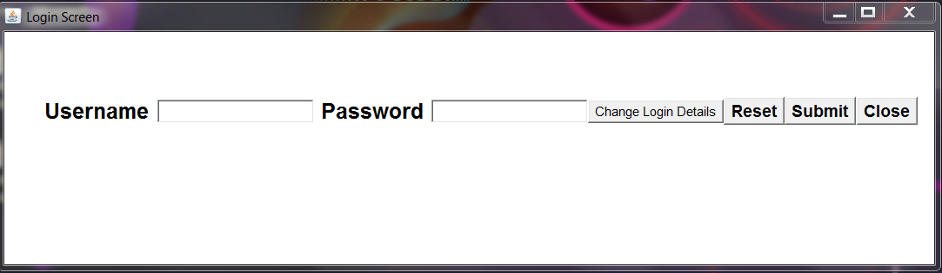

Fig no: 1. Fig title: Login screen of Airlines Reservation System

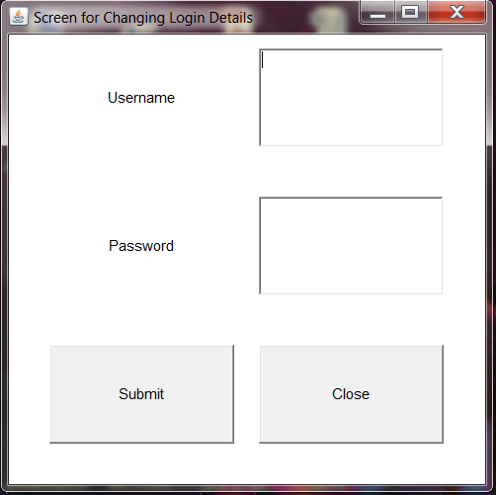

Fig no: 2. Fig Title: Change Login Details

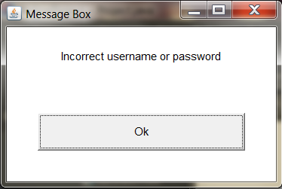

Fig no:3. Fig Title: Message Box

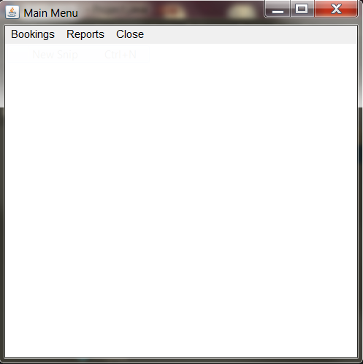

Fig no: 4. Fig title: Main menu of Airlines Reservation System

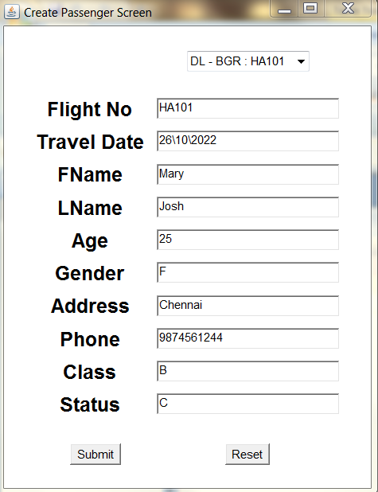

Fig no: 5. Fig title: Reservation screen of Airlines Reservation System

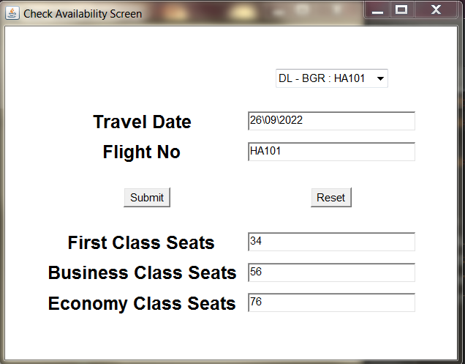

Fig no: 5. Fig title: Availability of seats



Fig no: 6. Fig title: Passenger details screen

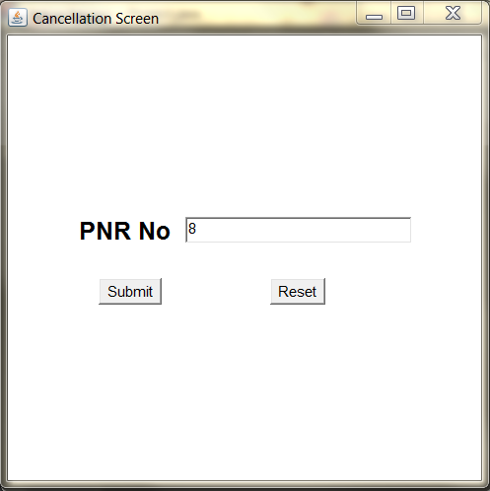

Fig no: 7. Fig title: Cancellation screen

**RESULT**:

Thus a JAVA application using Swing was developed and executed successfully.